Question 1
Set up the network topology as shown in Figure 1 where router R1 is to function as a DHCP server, DSW1 and DSW2 are distribution switches with redundancy so that if DSW1 or DSW2 is down, PCs in VLAN 10 and VLAN 20 are still able to communicate in the network.
With reference to the addressing table in Table 1, configure R1, DSW1, DSW2, SW1 and SW2 where necessary so that PC-A, when connected to SW1 on any port Gi1/0/2-11, will obtain suitable IP addresses for VLAN 10, and when connected on any port Gi1/0/13-23 will obtain suitable IP addresses for VLAN 20 from the DHCP server running on router R1.
Any additional users including internal attackers connected to any port Gi1/0/2-11 or Gi1/0/13-23 will also be able to obtain suitable IP addresses from the DHCP server R1 and ping PC-A
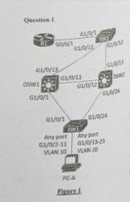
Device | Interface | IP Address | Subnet Mask | Default Gateway | DNS
R1 | Gi0/0/1 | 192.168.30.81 | /29 | - | -
PC-A | Gi1/0/2-11 | DHCP | /24 | 192.168.10.1 | 8.8.8.8
 | Gi1/0/13-23 | DHCP | /24 | 192.168.20.1 | 8.8.8.8

In addition, configure security on SW1 to defend against internal attackers from conducting:
- DHCP starvation attack on VLAN 10 only
- ARP poisoning attack on VLAN 20 only
When done, inform the examiner for demo (Only 1 try per question to be fair.)

Question 2
Set up the network topology as shown in Figure 2. Configure firewall FW1 and edge router R2 according to the given addressing table in Table 2 so that PC-B is able to access the Internet and an internal attacker is able to visit the Web Server hosted at PC-B.
Refer to Appendix A at the end of the paper for the interface IP address of R2 Gi0/0/0 connecting to the ISP for your network rack.
Similarly, refer to Appendix A for the public IP address block allocated for your network rack.
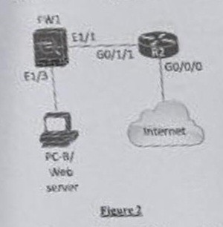
 | Interface | IP Address / Mask
R2 | Gi0/0/0 | Refer to Appendix A
 | Gi0/1/1 | Suitable IP
FW1 | E1/1 | 192.168.40.101/30
 | E1/3 | Suitable IP
PC-B | - | 192.168.50.202/29

Configure security on FW1 to defend against external attackers from conducting:
- Slowloris attacks on the web server
In addition, configure security on R2 to defend against PC-B from conducting:
- IP Address spoofing out to the Internet
When done, inform the examiner for demo (Only 1 try per question to be fair.)

Question 3
Combine the network topology in Question 1 and 2 together as shown in Figure 3. Do not remove routing configurations on the network devices.
Configure additional configurations on the network devices where necessary so that PC-A connected to any port on SW1 is able to surf the Internet.
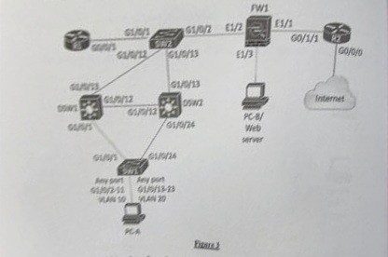
When done, inform the examiner for demo (Only 1 try per question to be fair.)

